
The Superior University

📝 Database Lab Project Documentation

1. Project Title
Volunteer management system

2. Group Members
List all team members with roll numbers:
- Hammad Arshad (SU92-BSAIM-F23-030)
- Muhammad Mehdi mesam (SU92-BSAIM-F23-004)

3. Project Overview
Our Volunteer Management System helps organizations manage their volunteers and events. Many non-profits and community groups struggle to keep track of which volunteers are assigned to different events, what roles they have, and how many spots are still available. Our system solves this problem by providing a simple way to manage organizations, events, volunteers, and their roles in one place. Users can register volunteers for events, assign specific roles, and see statistics about participation and event capacity.

4. Functional Requirements
- Organization management (add, view, search)
- Event management (create, update, view, search by organization)
- Volunteer management (add, search, view details)
- Event registration (register volunteers for events, cancel registrations)
- Role assignment (assign roles to volunteers for specific events)
- Dashboard stats (view upcoming events, volunteer participation stats)
- Database utilities (triggers, stored procedures, functions, views)

5. Tools and Technologies Used
- Python 3.9 (programming language)
- MySQL (database server)
- MVC architecture pattern (for code organization)
- MySQL Connector/Python (for database connection)
- Git & GitHub (for version control)
- Command Line Interface (for user interaction)

6. Database Design (ERD)
Our database has five main tables:
- Organizations - stores info about organizations that host events
- Events - contains events with details like date, capacity, location
- Volunteers - stores volunteer personal information
- Volunteer_Event - tracks which volunteers are registered for which events
- Volunteer_Roles - stores the specific roles assigned to volunteers for events
The relationships are:
- One organization can host many events (one-to-many)
- One volunteer can register for many events (many-to-many through Volunteer_Event)
- One volunteer registration can have many roles (one-to-many)

7. SQL Concepts Used

DDL (Data Definition Language)
We used DDL to create tables with proper constraints:
CREATE TABLE Organizations (
OrganizationID INT PRIMARY KEY AUTO_INCREMENT,
OrganizationName VARCHAR(100) NOT NULL,
Address VARCHAR(200),
Phone VARCHAR(15),
Email VARCHAR(100)
);

DML (Data Manipulation Language)
We implemented insert, update, and delete operations:
self.cursor.execute(
"INSERT INTO Organizations (OrganizationName, Address, Phone, Email) VALUES (%s, %s, %s, %s)",
(name, address, phone, email)
)

Joins
We used LEFT JOINs to combine data from related tables:
SELECT e.*, o.OrganizationName
FROM Events e
LEFT JOIN Organizations o ON e.OrganizationID = o.OrganizationID
ORDER BY e.EventDate DESC

Stored Procedures
We created stored procedures like RegisterVolunteerForEvent which handles the logic of checking capacity before registering:
CREATE PROCEDURE RegisterVolunteerForEvent(
IN p_volunteer_id INT,
IN p_event_id INT,
OUT p_registration_id INT,
OUT p_success BOOLEAN,
OUT p_message VARCHAR(255)
)
BEGIN

END

Functions
We made functions like GetVolunteerEventCount to calculate statistics:
CREATE FUNCTION GetVolunteerEventCount(p_volunteer_id INT)
RETURNS INT
BEGIN
DECLARE event_count INT;
SELECT COUNT(DISTINCT EventID) INTO event_count
FROM Volunteer_Event
WHERE VolunteerID = p_volunteer_id;
RETURN event_count;
END

Triggers
We implemented triggers to automatically update event registration counts:
CREATE TRIGGER update_event_count_after_insert
AFTER INSERT ON Volunteer_Event
FOR EACH ROW
BEGIN
UPDATE Events
SET RegisteredCount = (
SELECT COUNT(*)
FROM Volunteer_Event
WHERE EventID = NEW.EventID
)
WHERE EventID = NEW.EventID;
END

Views
We created views for common queries:
CREATE VIEW UpcomingEvents AS
SELECT
e.EventID,
e.EventName,
e.EventDate,
e.Capacity,
e.RegisteredCount,
o.OrganizationName
FROM Events e
LEFT JOIN Organizations o ON e.OrganizationID = o.OrganizationID
WHERE e.EventDate >= CURRENT_DATE()

8. Project Structure (MVC)
We used the Model-View-Controller pattern to organize our code:
• models/ – Database interaction logic
- organization_model.py – Handles organization CRUD operations
- event_model.py – Manages event data
- volunteer_model.py – Volunteer data operations
- volunteer_event_model.py – Manages volunteer event registration
- volunteer_role_model.py – Handles role assignments
- db_utils_model.py – Database utilities and SQL operations
• views/ – User interface implementation
- organization_view.py – Shows organization data to users
- event_view.py – Displays event data and forms
- volunteer_view.py – Shows volunteer lists and details
- volunteer_event_view.py – Registration interface
- volunteer_role_view.py – Role management display
- db_utils_view.py – Interface for database utilities
• controllers/ – Business logic layer
- organization_controller.py – Organization operations logic
- event_controller.py – Event management logic
- volunteer_controller.py – Volunteer management
- volunteer_event_controller.py – Registration business logic
- volunteer_role_controller.py – Role assignment logic
- db_utils_controller.py – Database utilities control logic
• config/ – Configuration and setup
- db_config.py – Database connection configuration
• app.py – Main application entry point with menu system

9. Screenshots of Code Output
- Main menu screen
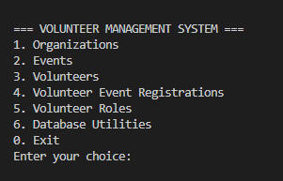
- Adding a new volunteer
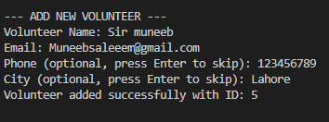
- Creating a new event
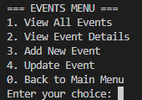
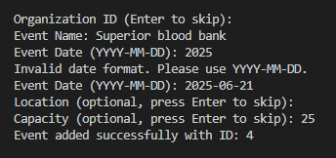
- Registering a volunteer for an event
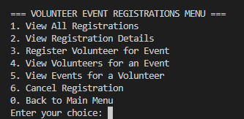
- Viewing event statistics
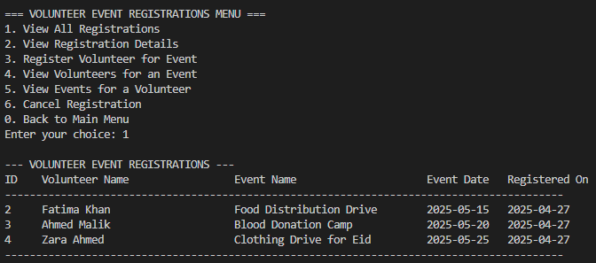

10. Challenges Faced
Database Connection Issues: At the beginning, we struggled with consistently connecting to the MySQL database. We fixed this by guidance of Sir muneeb saleem
MVC Structure: Initially, we weren't sure how to organize the code properly. After researching the MVC pattern, we reorganized our files and separated concerns between models, views, and controllers.

11. Conclusion
Our Volunteer Management System successfully implements a complete solution for managing volunteers and events.
In the future, we could improve the system by:
- Adding a web interface using Flask or Django
- Implementing user authentication and different access levels
- Adding email notifications for event reminders
- Creating reports and analytics features
- Adding a calendar view for upcoming events

12. GitHub Repository Link
Paste your working GitHub repo URL here.

